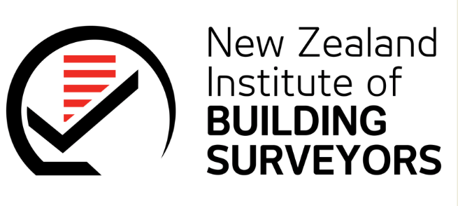 |  | 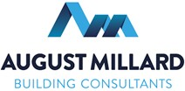

NZIBS: CPD WEBINAR - COVID 19

As we head towards alert level 1, the New Zealand construction industry has and is experiencing unprecedented challengers as a result of COVID 19. NZIBS would like to invite you to join a webinar CPD event Thursday 11 June. We have assembled a panel of industry experts to discuss and comment on the affects of COIVD 19 and the lockdown on the construction industry with a particular focus on NZS3910:2013 clauses.

Webinar Details
Thursday 11 June 2020
11am to 12pm.
To register: https://attendee.gotowebinar.com/register/1825703181344774414

This webinar is a free event and proudly sponsored by August Millard Limited

Our panel consists of,
 | Darryl August – Executive and Registered Member of NZIBS and Director at August Millard Building Consultants | 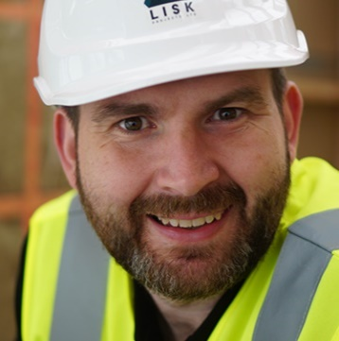 | Peter Moore – Project/Design Manager at Lisk Projects Limited.
 | David Clifton – Registered Member of NZIBS and Director at Commercial Services and Reports. |  | Pure Miller – Associate at Lane Neave Lawyers

Webinar Details
Thursday 11 June 2020
11am to 12pm.
To register: https://attendee.gotowebinar.com/register/1825703181344774414

This webinar is a free event and proudly sponsored by August Millard Limited

